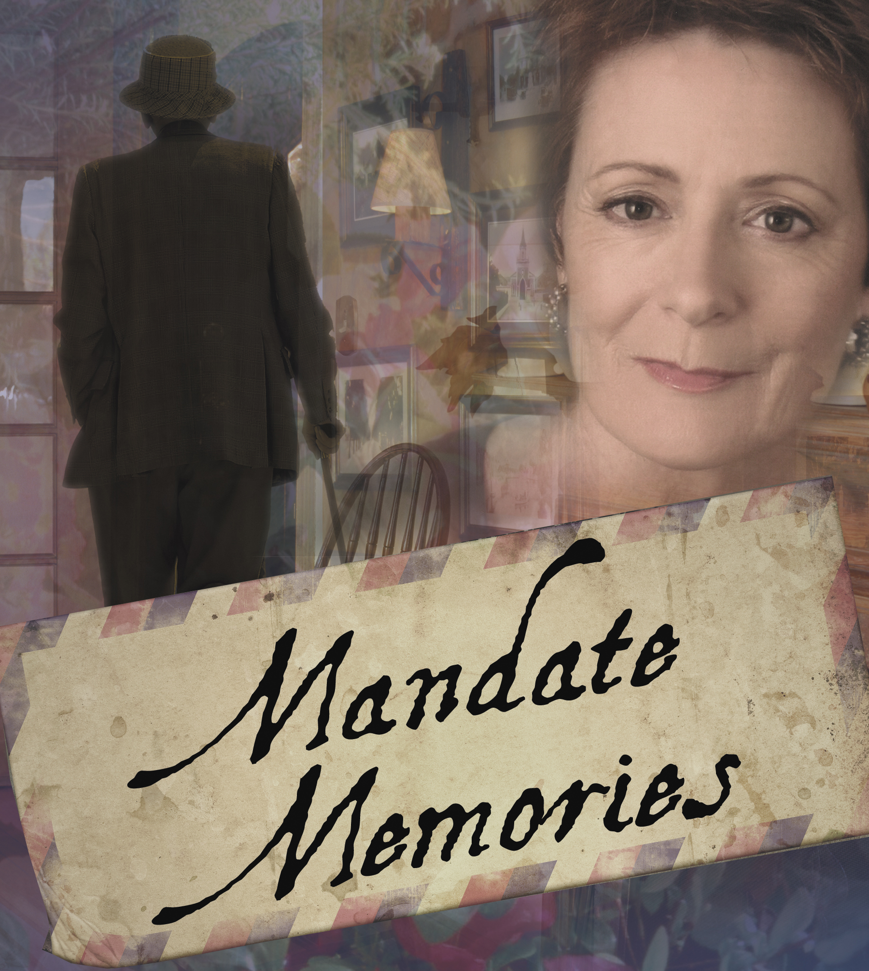
PRESS CONTACT:
Nancy Richards – 917-873-6389 (cell)/nancy@northcoastrep.org
MEDIA PAGE: www.northcoastrep.org/press
PHOTOS BY: Aaron Rumley

FOR IMMEDIATE RELEASE, PLEASE:
MYSTERIES REVEALED IN COMPELLING NEW DRAMA, MANDATE MEMORIES,
MAKING ITS WORLD PREMIERE AT NORTH COAST REP
BY LIONEL GOLDSTEIN
Performances Beginning Wednesday, April 9, 2014
With Opening Night, Saturday, April 12, at 8 PM
Running Through Sunday, May 4
Directed by DAVID ELLENSTEIN
SOLANA BEACH - British playwright Lionel Goldstein (Halpern and Johnson) creates another riveting two-character masterpiece, perfect for North Coast Rep’s intimate stage. In this taut and witty drama filled with revelations of love affairs, dreams and the founding of Israel, layers are peeled away to reveal the deep hearts of two caring and compassionate human beings. There is a mysterious connection between Gustav Frolich, an eighty-year-old Holocaust survivor and Jane Stirling, a sixty-two year-old widow as their debate reveals how different and yet how similar they are. Be among the first to see this world premiere.

Artistic Director David Ellenstein will direct Apollo Dukakis* and Rosina Reynolds* in Mandate Memories. The design team includes The design staff includes Marty Burnett (Scenic Design), Matt Novotny (Light Design), Alina Bokovikova (Costume Design), Melanie Chen (Sound Design), Benjamin Cole (Props), Peter Herman (Hair & Wig Design) and Cindy Rumley* (Stage Manager) comprise the crew.
*The actor or stage manager appears through the courtesy of Actors’ Equity Association, the union of professional actors and stage managers in the United States.

NOTE: The British Mandate for Palestine was, specifically, for a national home for the Jews. The British did not keep to the terms of the Mandate. They were severely pressured by the Arabs and in 1935 they decided to send a commission out under Lord Peel to consider the situation. The Peel Commission reported back to Parliament at the beginning of 1936. They recommended partition. The Jews in Palestine, seeing the writing on the wall in Germany (Hitler had been made Chancellor in 1933), agreed to the Peel proposals but the Arabs rejected it. Then, still under pressure, the British issued the infamous White Paper of 1939 which was clearly against the terms and spirit of the Mandate, and limited Jewish immigration. Had the terms of the Mandate been honored, who knows how many hundreds of thousands of Jews would have been saved from the gas chambers...
The Mandate terminated in 1948.
This production is made possible by the generosity of The Jeffrey & Sheila Lipinsky Family Foundation
Mandate Memories previews begin Wednesday, April 9th. Opening Night on Saturday, April 12th at 8pm includes a post-show reception. There will be a special talkback on April 18, 2014 with the cast and director. It will play Wednesdays at 7pm, Thursdays through Saturdays at 8pm, Saturday and Sunday matinees at 2pm with Sundays at 7pm, through May 4, 2014. (See Schedule below.) North Coast Repertory Theatre is located at 987 Lomas Santa Fe Drive, Suite D, Solana Beach, CA 92075. Tickets: Opening Night - $54, Previews- $37; Week Nights - $44; Sat. Eve. & Sun. Mat.- $48; Sat. Mat. & Sun. Night - $41. Seniors, Students, Military - $3 off admission. Call 858-481-1055 or visit www.northcoastrep.org to purchase tickets.

For background information and photos, go to www.northcoastrep.org/press.
Please follow North Coast Repertory Theatre on social media as well on Facebook at https://www.facebook.com/pages/North-Coast-Rep/128553240497901
Twitter: https://twitter.com/NorthCoastRep
YouTube: http://www.youtube.com/user/NCRTheatre?ob=0

Busy director David Ellenstein and his cast members are available for interviews by phone, in person, and in-studio. For more information and to arrange interviews or press tickets, please contact Nancy Richards at nancy@northcoastrep.org, or 917-873-6389 cell.

FACT SHEET

WHAT: NORTH COAST REPERTORY THEATRE presents
MANDATE MEMORIES
Written by LIONEL GOLDSTEIN
A World Premiere
Directed by David Ellenstein

CAST: Apollo Dukakis* and Rosina Reynolds*

WHERE: North Coast Repertory Theatre
987 Lomas Santa Fe Drive, Ste. D
Solana Beach, CA 92075

SCHEDULE*: Previews: April 9-11, 2014
Opens: April 12 @ 8pm
Closes: May 4, 2014
Wed. @ 7pm, Thurs-Sat @ 8PM; Sat & Sun @ 2PM, Sun @7pm
Talkback with cast & director: April 18, 2014

PRICES: Previews $37.00
Opening Night $54.00
Week Nights $44.00
Sat. Matinees & Sunday Nights $41.00
Sat. Nights & Sunday Matinees $48.00

DISCOUNTS: Seniors, Students, Military $3.00 off admission

BOX OFFICE (858) 481-1055 or www.northcoastrep.org

APRIL
M | T | W | T | F | S | S
 |  | 9  Preview 8pm | 10  Preview 8pm | 11  Preview 8pm | 12  OPENING  8pm | 13  2pm & 7pm
14 | 15 | 16  7pm | 17  8pm | 18  Talkback 8pm | 19  2pm & 8pm | 20  2pm & 7pm

21 | 22 | 23  7pm | 24  8pm | 25  8pm | 26  2pm & 8pm | 27  2pm & 7pm

28 | 29 | 30  7pm | May 1  8pm | May 2  8pm | May 3  2pm & 8pm | May 4  2pm

BACKGROUND:
North Coast Repertory Theatre’s 2013-2014 -Season 32 runs September 4, 2013, through August 3, 2014. Up next is the World Premiere of FADED GLORY, which previews on May 28 and runs till June 22. Meet Daniel Sickles, a 19th-century congressman, friend to presidents, Civil War general, lover of Queen Isabella of Spain, notorious philanderer, embezzler, murderer, and the officer who almost cost the Union victory in perhaps the most pivotal battle of the Civil War, only to receive the Congressional Medal of Honor. Based on this real figure from American history, funny, poignant and filled with astonishing little-known historical information, FADED GLORY promises to be a highlight of our season. Audiences will enjoy a rollicking comedic romp through this amazing life. The season will end with ROMANCE/ROMANCE beginning on July 9 to August 3. Frothy and fun, this musical reminds us of those secret, frivolous, and embarrassing romantic impulses to which we are susceptible. In this rousing two-act musical we take a varied look at romance seekers in two ways: from a delightful romp through the sexual ennui of the turn of the century Vienna in the first act, to a second act modern look at affection and disaffection in a summer house in the Hamptons. An Off-Broadway sensation that successfully moved to Broadway, ROMANCE/ROMANCE is a sweetheart of a musical perfect for North Coast Rep’s intimate stage.

About the North Coast Repertory Theatre
North Coast Repertory Theatre is a professional Equity theatre founded in 1982 by Olive and Tom Blakistone. Currently celebrating its 32nd season, North Coast Rep has received critical acclaim from media and audiences alike, and has evolved into one of the area’s leading performing arts organizations. North Coast Rep prides itself on employing the majority of its actors from Actors’ Equity Association for its high quality, award-winning productions, and staging works by established and emerging playwrights. Throughout its history, North Coast Rep has created a platform where artist and audience thrive through the intimacy of live theatre, recognizing the power of theatre to challenge complacency, revitalize the imagination, nurture the unexpected and embrace the variety and diversity in our lives.
#####
BIOS
Lionel Goldstein (Playwright) was born August 1935 in London’s East End (UK). The Second World War commenced at the same time as primary school and as he was evacuated from London several times during hostilities, (the periods in various provincial towns around England always coincided with a general lull in air hostilities, whereas his periods in London were invariably at the same time as the Luftwaffe deciding to engage in bombing runs), he hardly attended school at all. When the War ended, he was, ‘not in the habit and couldn’t wait to leave’. Which he did, just before his fifteenth birthday. Lionel had a succession of jobs and short careers: furrier, ladies’ hairdresser, a spell as a barber/hairdresser in the British Merchant Navy, slot machine repairman, motor parts warehouseman, antique silver dealer, electrician, laborer, painter and decorator, property developer. He started writing short stories aboard ship when he was 19. When he was 26, he wrote a novel, the first of four. “The Man Before Yesterday” was his third novel and was first published in the United Kingdom is 1991. It is now available on Amazon. He adapted his second novel, “The Executioner,” into a TV play, which was produced by the BBC in 1980. Since then, Lionel has enjoyed being a full-time writer for television and stage. His second play for TV, Halpern & Johnson, was made by HBO/HTV and starred Lord Laurence Olivier and Jackie Gleason. Lionel adapted the play for the stage and it has enjoyed world-wide success including productions in the USA, Australia, Israel, South America, Vienna, Berlin — and many other regional theatres in Germany — Madrid, Moscow, Paris, Montreal and London. It opened in Prague Feb. 28. He has adapted his second stage play, Mandate Memories, into an expanded version, titled The Last Mission, which is due to be performed in Tel Aviv, Israel this summer. Lionel married in 1969 and divorced in the early 80’s. He has two daughters who both live in Toronto. Lionel lives in London, England.

David Ellenstein (Director) Born into a theatrical family, David has worked in theatres across the country. Before joining North Coast Rep in 2003 he served as Artistic Director for the Los Angeles Repertory Company and the Arizona Jewish Theatre
Company (AJTC). A veteran of over 200 theatrical productions, directorial favorites include: North Coast Rep – Becoming Cuba (World Premiere), Time Stands Still, Words by: Ira Gershwin and the Great American Songbook (World Premiere), Two by Pinter: The Lover and The Dumb Waiter, HENRY IV Part 1, Heroes, My Name is Asher Lev, The Drawer Boy, Becky’s New Car, Ghosts, The Tempest, Talley’s Folly, Over the Tavern, Old Wicked Songs, The Dresser, Jacques Brel is Alive and Well and Living in Paris, Madagascar, A Shayna Maidel, The Honky Tonk Angels, Rashomon, A Moon for the Misbegotten; Tuesdays With Morrie; Collected Stories; Halpern and Johnson; Romeo and Juliet; Amy’s View; Einstein Comes Through (also co-author); The Chosen; A Life in the Theatre; Story Theatre and Charley’s Aunt. Coconut Grove Playhouse - Sonia Flew starring Lucy Arnaz; Halpern and Johnson starring Hal Linden and Brian Murray. Papermill Playhouse - The Chosen starring Theodore Bikel and John Lloyd Young. Portland Stage - Halpern and Johnson. Renaissance Theatre - Long Day’s Journey Into Night. Actor’s Theatre of Phoenix – Rabbit Hole. Alabama Shakespeare Festival - Rocket City (World Premiere) and Honky Tonk Angels. Laguna Playhouse - Alexandros (World Premiere). Southwest Shakespeare Company - Cyrano de Bergerac. AJTC - Awake and Sing. Meadow Brook Theatre - A Christmas Carol. Portland Rep - Conversations With My Father and Gaslamp Quarter Theatre - A Shayna Maidel.
This Artist is sponsored by Jay & Julie Sarno

Apollo Dukakis* (Gustav Frolich) has been a professional actor for over forty years. He has appeared extensively in regional
theaters across the country including the Mark Taper Forum, Pasadena Playhouse, American Conservatory Theater, Actor's Theater of Louisville, Cleveland Playhouse, Trinity Repertory Company, Williamstown Theater Festival, Dallas Theater Center, Denver Theater Center, The Hollywood Bowl, The Getty Villa, Arizona Theater Company, and Shakespeare and Company in Lenox Mass where he was Gonzalo in The Tempest and the Chaplain in Mother Courage, both opposite his sister, Olympia Dukakis. He is a co-founder and was Associate Artistic Director, actor, director and teacher with the Tony-nominated Whole Theater of New Jersey for fifteen years. In Los Angeles, as a resident artist with the award-winning A Noise Within, he was Sir Toby Belch in Twelth Night, Argan in Imaginary Invalid,
VanderGelder in The Matchmaker, Mangan in Heartbreak House and Father Dewis in Buried Child (Dramalogue Award) among others. He was Lear in King Lear and Shylock in Merchant of Venice for Shakespeare Santa Monica. As a member of LA's Antaeus Classical Ensemble, he was the King in Exit the King (L.A. Drama Critics and Ovation award nominations}, John in Rhinoceros, and the father in Pera Palas. T.V. appearances include Seinfeld, E.R., and Shadow of the Blair Witch. In film, he was Polonius opposite, Arnold Schwarzenegger in The Last Action Hero and American Heart with Jeff Bridges.
This artist is sponsored by Sheryl and Harvey White

Rosina Reynolds* (Jane Stirling) Previous shows at North Coast Repertory Theatre: Who Am I This Time, Ghosts, Madagascar, Wit,
Amy's View,The Rivals, Eleanor. Regional Theatre: 33 Variations (Theatreworks), Love In American Times (San Jose Rep), Steel
Magnolias (La Mirada Theatre), Dividing the Estate, Sea of Tranquility, Romeo and Juliet, Missing Footage, Trojan Women, (Old Globe
Theatre), Doubt, The Clean House, Cymbeline, A Lovely Sunday at Creve Couer, Christmas Carol; (San Diego Repertory Theatre;) San
Diego Theatre: The Glass Menagerie, Noises Off, Arcadia, Copenhagen, The Little Foxes; (Cygnet Theatre); Joyful Noise, Lettuce & Lovage, Woman of No Importance. (Lambs Players Theatre) Shirley Valentine, Long Days Journey Into Night, (Renaissance Theatre
Company). Other San Diego theatres include New Village Arts, Mo’olelo Performing Arts Company, Sledgehammer Theatre, Malashock Dance Company and Moonlight Avo. Rosina has directed over 30 productions in San Diego including the recent production of Broken Glass here at NCRT. She is the founding Artistic Director of the Chequamegon Children’s Theatre in Northern Wisconsin, where they produced their 28th production, Fiddler on the Roof, last summer.
This artist is sponsored by Sharon and Richard Leib

Marty Burnett (Resident Designer) begins his 22nd season as Resident Designer/ Technical Director at North Coast Rep. He has designed the last 150 shows. Other venues include Laguna Playhouse, Portland Stage Company, Drury Lane (Chicago), Claridge Hotel (Atlantic City), Union Plaza, Sahara Hotel, Hacienda in Las Vegas, Coronado Playhouse, Scripps Ranch Theater, Harrah’s Lake Tahoe. Marty is a proud alumni of Creighton University in Omaha, Nebraska.

Matt Novotny (Light Design) recently designed the lighting for Who Am I this Time?, Broken Glass, Man With A Load Of Mischief, Perfect Wedding, Becoming Cuba, The Odd Couple, Time Stands Still, Educating Rita, The Underpants, Dames at Sea, Two by Pinter: The Lover and The Dumb Waiter, THIS, Visiting Mister Green, Lend Me A Tenor, Five Course Love, My Name is Asher Lev, King O’ the Moon, Ghosts, Glorious, I Love You Because, Old Wicked Songs, Rabbit Hole, Shipwrecked!, The Dresser, Don’t Dress for Dinner, Mornings at Seven, Baby and Rashomon at North Coast Rep. He’s currently the Director of Production for Lyric Opera San Diego. Lighting designs include: Iolanthe, The Merry Widow, The King and I, Countess Maritza, and The Mikado. San Diego: Das Barbecu, The Wiz, West Side Story and Rumors. Regional: Yankee Doodle Dandy (Seattle), Noises Off! (Boston), The Game, (Washington D.C.) and Primal Twang, a guitar concert featuring six Grammy-winning artists. Matthew holds a B.A. in Technical Theatre from San Diego State University, and an M.F.A. from Boston University.

Alina Bokovikova (Costume Design) is thrilled to work with North Coast Repertory Theatre again. Her recent design credits include The School For Lies, Broken Glass, Words By, The Underpants, This, Henry IV. She has designed about 50 different productions A Doll’s House (The Old Globe), References to Salvador Dali Makes Me Hot, A Man, His Wife, and His Hat and A Raisen in a Sun (MOXIE Theatre), The Playwrights Project, Excavating Escondido, Hedda Gabler, Joe Turner’s Come and Gone, Camino Real (Patte’ Award) (La Jolla Playhouse and UCSD). She loves to experiment with everything: musicals The Great Americn Trailer Park Musical, Beehive, film Stereoblid, the ballet Les Noces or the opera La Traviata. Ms.Bokovikova has an M>F>A> in Costume design From UC San Diego and a Masters Degree in Education from Russia. She is an instructor of costume design at UC San Diego and history of costume at Fashion Institute of Design & Merchandising.

MELANIE CHEN (Sound Designer) is currently pursuing her MFA degree for sound design at the University of California, San Diego. She has experience recording and mastering voiceovers, working with body microphones, mixing musicals, and creating
sound designs for live theatre and dance productions. UCSD credits: Drums in the Night, Casagemas (New Play Festival ’12), Tonight We Improvise, In the Red and Brown Water, Hookman (New Play Festival ’11). Select San Diego regional theatre: Becoming Cuba
(North Coast Repertory Theatre), Bengal Tiger at the Baghdad Zoo (ion theatre company), One Flew Over the Cuckoo’s Nest (New Village Arts), Blasted (ion theatre company — Craig Noel Nomination ‘12), Angels in America Part 1 & 2 (ion theatre company — Craig Noel Award ’11). Recently, she assisted Drama Desk Award winner and Tony nominated sound designer Cricket Myers and award-winning composer Michael Roth on La Jolla Playhouse’s production of Sideways, written by Oscar winner Rex Pickett and directed by Tony Award winner Des McAnuff.

Peter Herman (Hair & Wig Design) has previously designed wigs for over 30 North Coast Rep productions including Honky Tonk Angels, Travesties, I Love You Because, Little Women, My Name is Asher Lev and recently Five Course Love. He has also designed costumes for past North Coast Rep productions of 25th Annual Putnam County Spelling Bee, The Big Bang, Madagascar, and Jacques Brel is Alive and Well and Living in Paris. Peter teaches wig and makeup design at San Diego State University. He is glad to be part of the creative team on this show.

Cindy Rumley* (Stage Manager) – Stage Management credits include Dames at Sea, Two By Pinter, and Visiting Mr. Green with North Coast Rep. Snapshots with The Pico Playhouse, Bye Bye Birdie with San Diego Musical Theater, and Conference of the Birds with The Moscow Art Theater. Cindy has worked as a production assistant at North Coast Rep for Heroes, My Name is Asher Lev, 5 Course Love, King O’ the Moon, and The Drawer Boy. Cindy holds an M.F.A in stage management from UC Irvine and is a member of Actor’s Equity Association. In her free time, Cindy enjoys being married to the amazing Mr. Aaron Rumley.
This artist is sponsored by Mrs. Judith G. Tullie

#####

